**Exercise 01**

Create the following Web page. You may use images and quotes as per your wish.

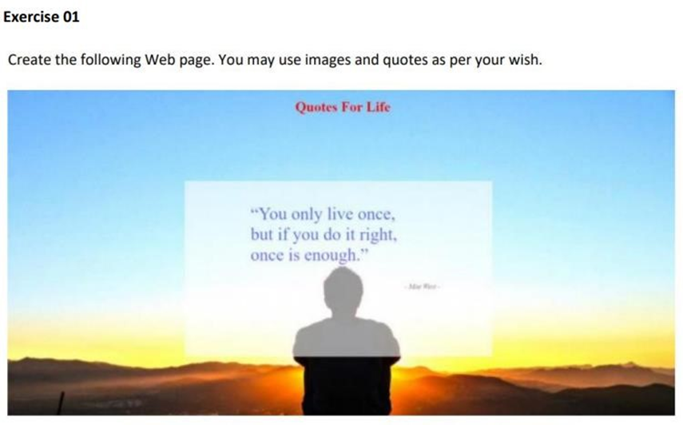

<html>

<head>

<title> Quotes For Life </title>

<style>

.banner-card {

position: relative;

}

.banner-card img {

display: block;

margin-left: auto;

margin-right: auto;

width: 60%;

height: 55%;

}

.banner-text {

position: absolute;

top: 0%;

left: 43%;

}

.red {

color: red;

text-align: center;

}

</style>

</head>

<body>

<div class="banner-card">

<img src="sunset.jpg">

<div class="banner-text">

<h5 class="red"> Quotes For Life </h5>

<blockquote>

<p>"You only live once,</p>

<p>but if you do it right,</p>

<p>once is enough."</p>

</blockquote>

</div>

</div>

</body>

</html>

**Exercise 02**

Create the following web page using HTML & CSS.



html

<html>

<head>

<title> Login Form </title>

<link rel="stylesheet" type="text/css" href="style.css">

</head>

<body>

<div class="loginbox">

<h1 class="black"> Sign Up </h1>

<form>

<table class="yellow">

<tr>

<td> First Name </td>

<td>

<input type="text" name="" placeholder="Enter First Name">

</td>

</tr>

<tr>

<td> <br> Last Name </td>

<td>

<br><input type="text" name="" placeholder="Enter Last Name">

</td>

</tr>

<tr>

<td> <br> Date of Birth </td>

<td>

<br> <select>

<option> Date </option>

</select>

<select>

<option> Month </option>

<option> January </option>

<option> February </option>

</select>

<select>

<option> Year </option>

</select>

</td>

</tr>

<tr>

<td> <br> Gender </td>

<td>

<br><input type="radio" name=""> Male <input type="radio" name=""> Female

</td>

</tr>

<tr>

<td> <br> Country </td>

<td>

<br> <select>

<option> Country </option>

<option> Sri Lanka </option>

<option> America </option>

</select>

</td>

</tr>

<tr>

<td> <br> E-mail </td>

<td>

<br> <input type="text" name="" placeholder="Enter E-mail">

</td>

</tr>

<tr>

<td> <br> Phone </td>

<td>

<br> <input type="text" name="" placeholder="Enter Phone">

</td>

</tr>

<tr>

<td> <br> Password </td>

<td>

<br> <input type="password">

</td>

</tr>

<tr>

<td> <br> Confirm Password </td>

<td>

<br> <input type="confirm password">

</td>

</tr>

</table>

<p class="pink"><input type="checkbox"> I Agree to the Terms of use</p>

<p class="dark"><input type="submit" value="Submit" class="green">

<input type="submit" value="Cancel" class="red"></p>

</form>

</div>

</body>

</html>

css

body {

margin: 0;

padding: 0;

background: url('wolf in mountains.jpg');

background-size: cover;

background-position: center;

font-family: sans-serif;

}

.loginbox {

width: 360px;

height: 560px;

background: #141e3c;

color: #fff;

top: 50%;

left: 50%;

position: absolute;

transform: translate(-50%, -50%);

box-sizing: border-box;

}

.black {

background-color: #f9850b;

text-align: center;

margin: 3%;

}

.yellow {

color: #e2bd4e;

margin: 2%;

}

.pink {

color: #e2bd4e;

text-align: right;

}

.dark {

background: #f9850b;

margin: 2%;

}

.green {

background: green;

width: 25%;

height: 7%;

color: white;

margin: 5%;

}

.red {

background: red;

width: 25%;

height: 7%;

color: white;

}